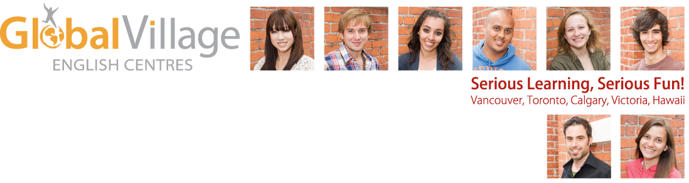

Global Village Toronto (Bloor/Avenue Rd.)
GLOBAL VILLAGE TORONTO IS HIRING SUPPLY ESL TEACHERS
GLOBAL VILLAGE TORONTO IS NOW HIRING!
(AVENUE ROAD AND BLOOR)

Come and be a part of the best ESL team in the city!!
Global Village Toronto is one of the largest private English as a Second Language schools in Toronto and a proud member of the community of Global Village English Centres. We are committed to quality of the highest standard in the areas of academics and services.
We are currently looking for qualified ESL teachers to join our supply list, with the opportunity for full-time hours in the spring. Top candidates will share our passion for delivering exceptional education and customer service to our international students.
Qualifications: Teachers must have a B. A. or 3 year College Diploma, a TESL certificate from a TESL Canada or Languages Canada recognized institution, and a minimum of one year teaching experience. Experience teaching IELTS, Cambridge Test Preparation, EAP is a plus. In addition to our supply list, we are also conducting interviews for positions in our summer Teen Activity Program.
We offer teachers highly competitive wages, paid preparation time, benefits for full-time staff, a mentor teacher program, a solid curriculum, over 300 resource books, a comfortable, fun atmosphere and a great team environment.
If you are interested, please send your resume and cover letter to our Assistant Director of Studies, Sara Potkonjak, at jobstoronto@gvenglish.com.
Visit our website for more information about Global Village English Centres at:
www.gvenglish.com

